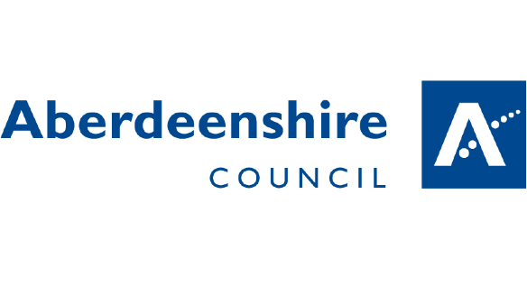

Methlick Primary School:
Building positive behaviour and positive relationships.

At Methlick School, we believe the promotion of positive relationships and behaviour is the responsibility of all school staff and the wider community. Mutual support, consistency and communication are essential elements of our ethos and procedures.
Our Vision
Everyone at Methlick will be GREAT
Our Values & Aims
We will:
Grow: Grow in knowledge, mindset and skills
Respect: Be Ready Safe and Kind.
Experience: Experience learning in lots of different ways
Achieve: Be encouraged and supported to achieve our potential.
Together: All learn together to be GREAT
Our Approach
All staff and parents promote good relationships and will praise children who display our values through their actions and words. Consistency is the key to building positive relationships at Methlick School and all adults agree that the following is embedded in our practice.
- Consistent Positive Reinforcement: Routine procedures for reinforcing, encouraging and celebrating appropriate behaviour.
- Consistent Language: All conversations regarding behaviour refer to our school values.
- Consistent Follow up: All staff are responsible for interventions and never automatically pass challenging behaviour up the line.
- Consistent Respect from Adults: Even if faced with challenging learners.
- Consistent Models of Emotional Control: Emotional restraint is modelled by adults and not just taught.
- Consistently Reinforced Routines: In classrooms and around the school.

Recognition of upholding our values:
Following consultation with staff and pupils, we recognise children displaying our school values in any of the following ways:
- Special mention at assembly for upholding our values.
- Seesaw post to parents.
- Certificate and sticker.
- House points.
- Verbal recognition from staff.
- Nomination from peers or staff for a Great Award.
- Name written in the Great Book of Methlick.

Reflect / Repair / Reconnect
When behaviours go wrong, we use restorative approaches to reflect, repair and reconnect. This approach involves finding a solution to the problem instead of focussing on blame. Focus is put on the reasons, causes, responsibilities, who has been affected and how can we put it right and move forward?
The following process is the agreed restorative procedure at Methlick Primary.
1st Verbal reminder of behaviour- reminder of values.
2nd Verbal reminder of behaviour- reminder of values.
Shared Script conversation- focussing on positive reinforcement and understanding of actions.
Behaviour think sheet or chat with HT- whichever is age and stage appropriate.
Contact parents if behaviour continues and there is cause for concern.
Shared Script.
This conversation will be led by staff with any pupil with relationship or behaviour concerns. The wording will be age and stage appropriate.
I noticed your behaviour is not reflecting our values. Can you explain what you are doing that worries me?
Because of this… (share the consequence or sanction that will be applied- staff member will decide the appropriate sanction depending on the situation.)
Do you remember last week when you ……. (Provide an example of positive behaviour)
This is what I need to see today from you… (Give clear direction about the positive behaviour you expect now) Thank you.
Bullying
Bullying is the repeated use of the power to hurt, frighten or cause distress. It can be emotional, verbal or physical.
At Methlick School we will thoroughly investigate any incident of bullying in a timely manner and we will share the results with those concerned with a focus on planning an appropriate response and a positive way forward for all.
Any incident of bullying should be referred, in the first instance to the class teacher. The class teacher will find out as much information as possible by listening to the child/parents/careers who have made the allegation.
The class teacher will liaise with the Head Teacher to discuss the allegations and an investigation will be carried out.
Once the investigation has been carried out the school response may include:
- Meetings with the child and parents/carers of all concerned to discuss the allegations, information and evidence found.
- A review of support needs for one or more of the children involved.
- It may be necessary to plan a monitoring and review date.
It is vital that all pupils feel confident to speak out and be able to speak to any members of staff. At Methlick School we aim to promote a caring ethos where every child and adult feels valued and is treated as an individual. We will be proactive in our actions and procedures to prevent bulling from happening.
Zero Tolerance
At Methlick school we support all staff members through Aberdeenshire Council’s Zero Tolerance Promise. No staff member should be subjected to violence, aggression, bullying or harassment either verbally, physically or emotionally while at their place of work. We promote and expect positive relationships and behaviour between all staff members and between staff and family members within our school community.
Further information can be found using the following links:
www.aberdeenshire.gov.uk
https://respectme.org.uk/
http://publications.aberdeenshire.gov.uk/dataset/b9bb8c35-50b7-401e-a7e3-30833f69cc73/resource/8d5ff96d-775f-4516-9f6b-c15ce425f407/download/anti-bullying-policy-and-guidance.pdf
https://www.bullying.co.uk/advice-for-parents/#

