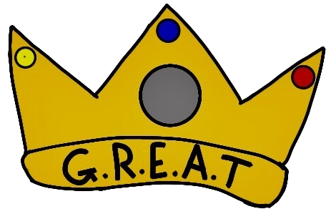

Our Vision at Methlick is that everyone will be:
G.R.E.A.T.
Our Values and Aims are that everyone will:
Grow- Grow in knowledge, mindset and skills
Respect- Be Ready Safe and Kind in all our words and actions.
Experience: Experience learning in different ways.
Achieve: Be encouraged and supported to achieve our potential.
Together: All learn together to be GREAT.

Our GREAT logo was designed by pupils after hearing the story of the Kellie Pearl, the River Ythan and the Scottish Crown Jewels.

