What happens when our behaviour is GREAT? | What happens when our behaviour is not so GREAT?
Shout out at assembly  Round of applause  House Points  Certificate and a sticker  Praise from an adult  Name recorded in the GREAT book | 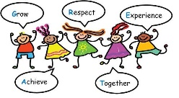  Reminder of our values  Repair, reflect and restore conversation  Think sheet  Stay in at break or lunch  Talk with Mrs Fraser  Parents called to discuss behaviour.

